**ACTIVITY #2**

Our team is Team 4 and is called “Tech Solutions” which is a recursive acronym that stands for “Tech Store is Our Team”, like YAML or GNU. Our team consists of:

* Pardo Salazar Romulo Agustin
* Pila Iza Narcisa Nataly
* Pilligua Chiliguano Washington Alejandro
* Romero Mesias Cristhian Augusto

We’ll explain our work related to each if the items considered in the Rubric

1. **GitHub Repository**

Our Project can be accessed here:

<https://github.com/RomulinhoPardo/ESPE2210-WADIT8516-T4-TECH-STORE.git>

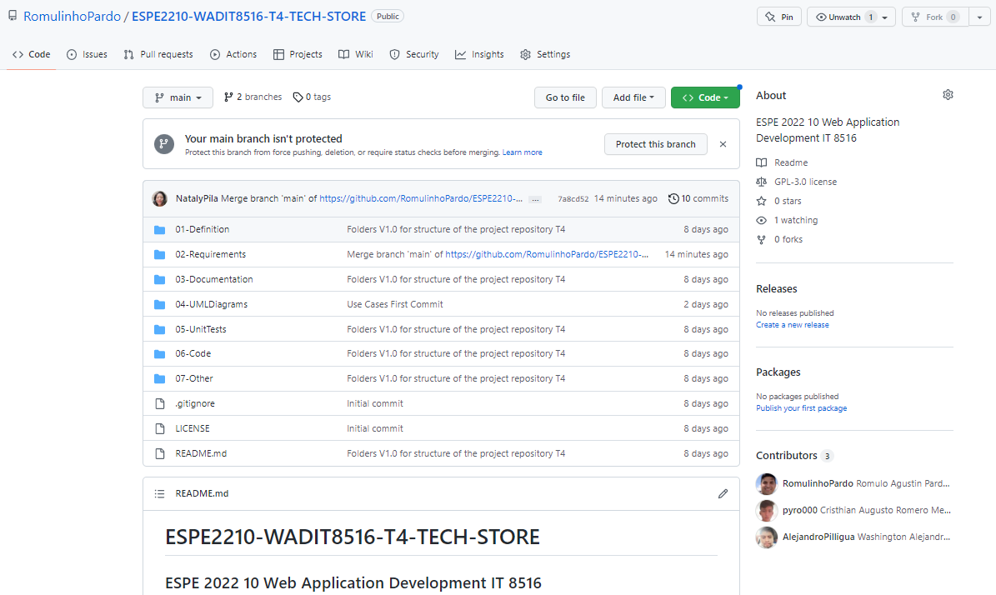

We followed the structure of files which allowed us to develop the software from Definition until Deployment in the Cloud.

1. **Idea (interview) and list of features (product Backlog)**

The interview is a very useful tool to know the needs of the client.

List of features.

* User authentication.
* Manage users.
* Manage products.
* Customer management

**Interview with the owner of the Tech Store business**

Online interview with the owner of Tech Store

**[](https://www.youtube.com/watch?v=1-yV6cv0JmQ)**

<https://www.youtube.com/watch?v=1-yV6cv0JmQ>

**Being an online interview, we do not have photos of the business, but we do have your logo.**



1. **Diagrams (Classes, Use Cases, Architecture)**

Through use cases we can describe the steps or activities to be carried out in each process. Use

* **Cases Diagram**

**User Login**

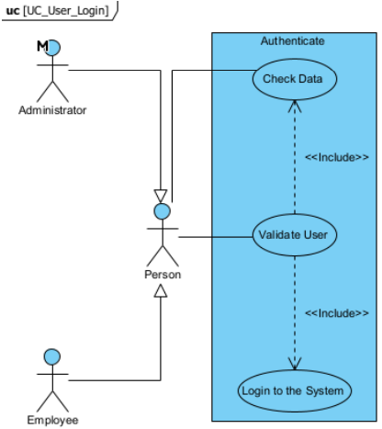

**User profile management**

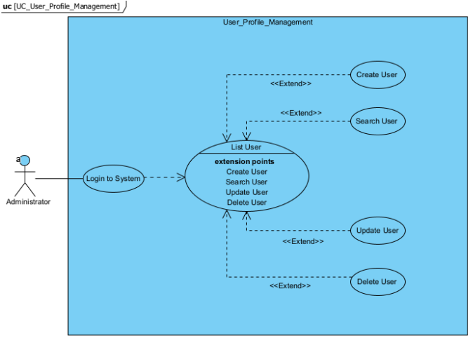

**Manage products**

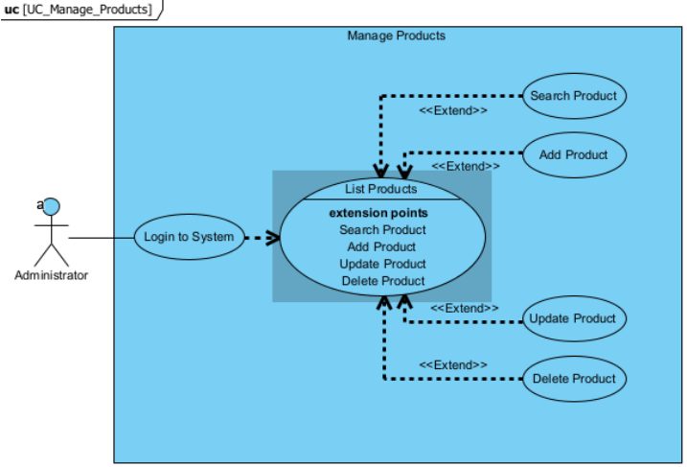

**Manage price**

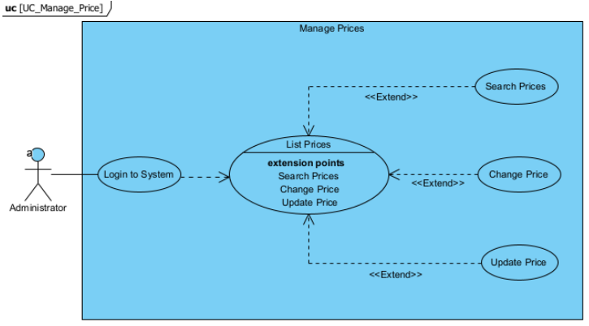

* **Class Diagram**

The classes that make up the Web Application are described below, as well as its methods and attributes.

* **And this is the general Architecture we followed:**

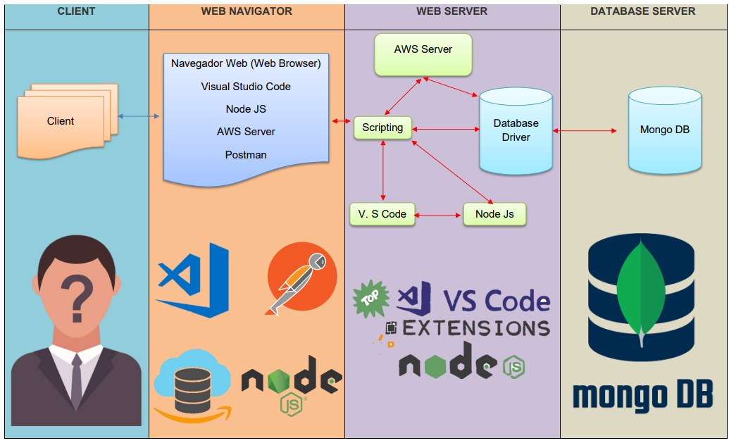

1. MongoDB Atlas Database (in the cloud) We created the Mongo Database using Atlas. It has 4 Collections for the 4 Classes or web app uses.

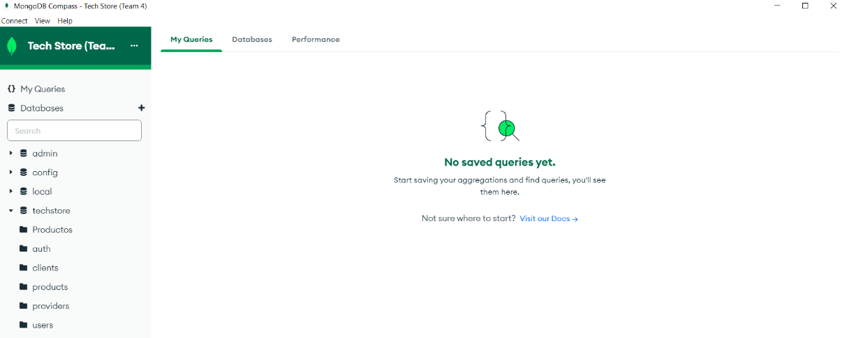

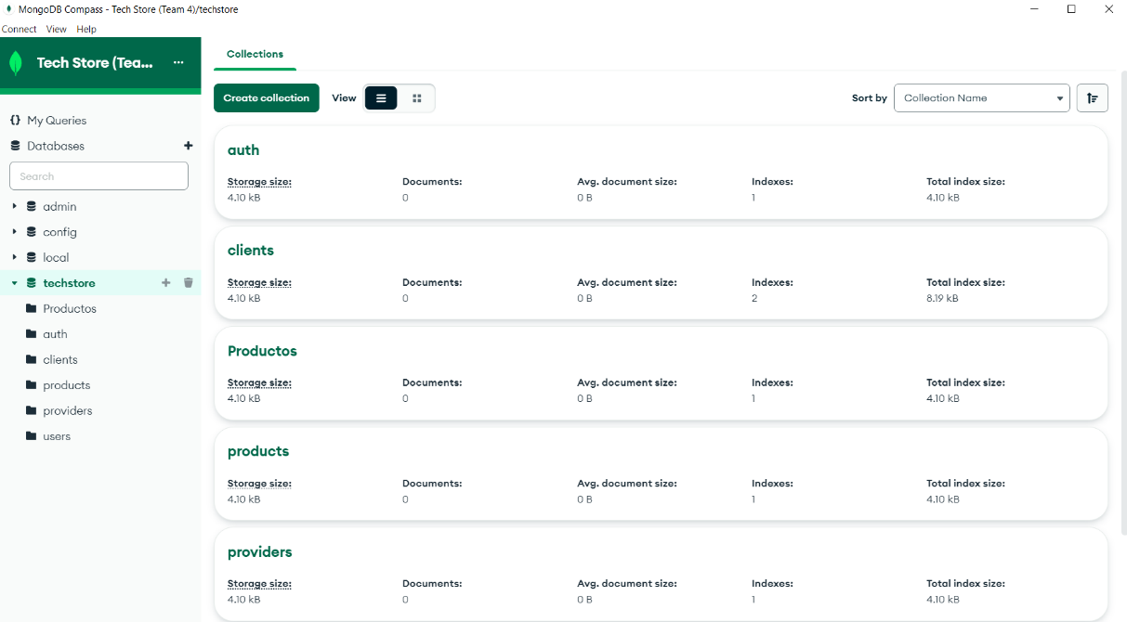

**mongodb+srv://Team4:<Team4>@clusterteam4-wadit8516.o0rg1oy.mongodb.net/techstore?retryWrites=true&w=majority**

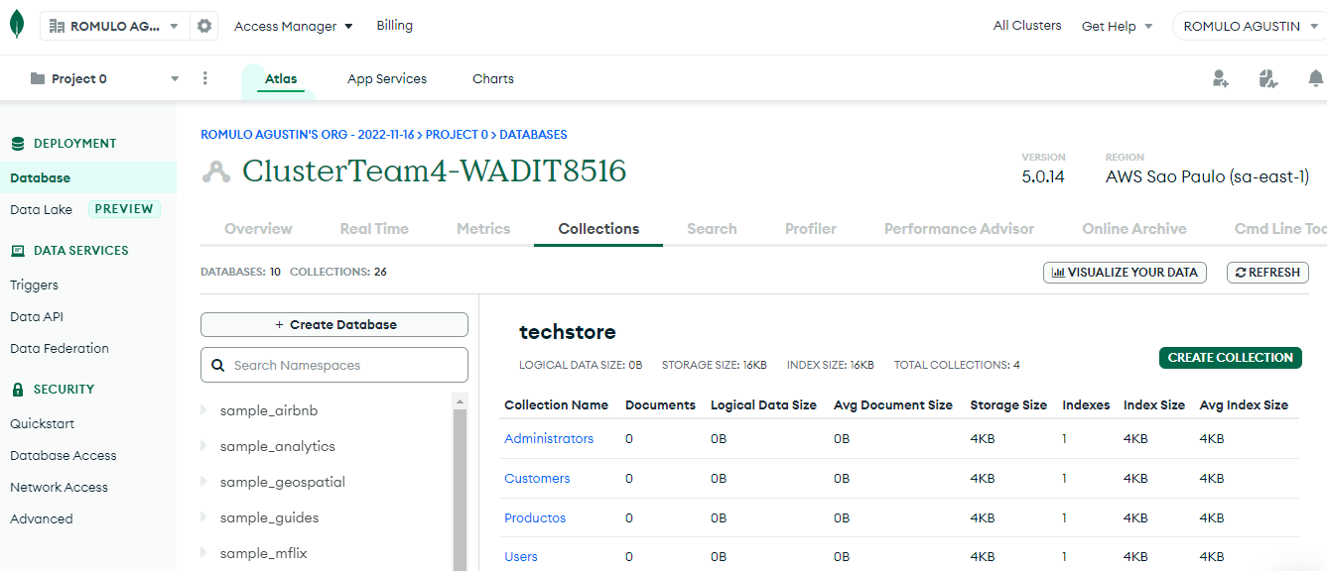

1. Design of the client and at least four business rules

For the structure of the views of the Web Application, a sketch was made of each one on Figma.

Business rules

* **Apply discounst.**
* Calculate stock.
* Calculate full value.
* Calculate employee commissions.

1. Execution of the application in the cloud or hosting.

<http://unixteam.tk:8080/TECHSTORE/index.jsp>

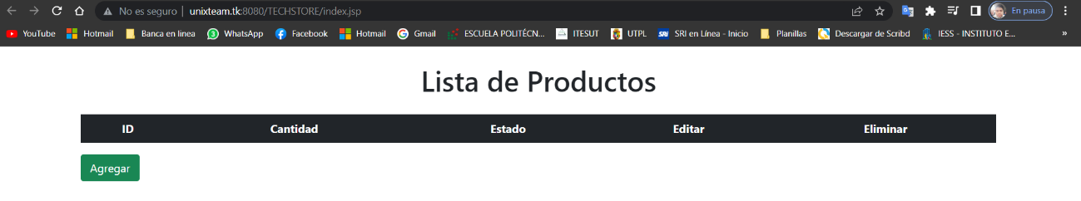

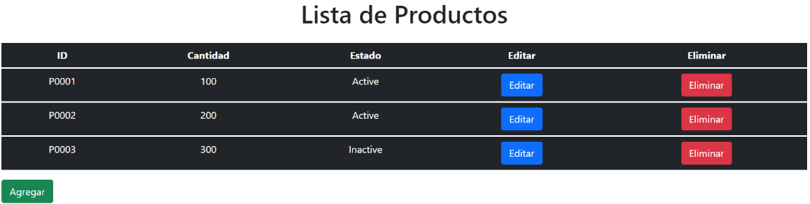

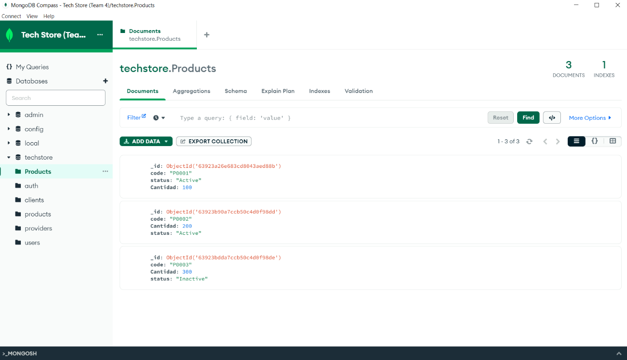

Video Link: <https://drive.google.com/drive/folders/1CwIPmCOOL0UR-eZmUi4lUx1x7RkRa_hv?usp=share_link>